Community Safety and Serious Violence Strategy Consultation Results
Overview
Reading’s Community Safety Partnership is a statutory multi-agency partnership that works to prevent and tackle crime and disorder in the town. The partnership provides the platform for these groups to work together to address priority issues and make Reading a safer place to live, work and visit. The Partnership includes Reading Borough Council, Thames Valley Police (Reading Local Police Area), The Probation Service (South Central), Royal Berkshire Fire and Rescue Service, Buckingham, Oxfordshire and Berkshire West Integrated Care System (BOB ICS), Brighter Futures for Children and representatives from Berkshire NHS Foundation Trust, along with a range of partners from Reading’s thriving Voluntary and Community Sector.
The partnership has developed its new Community Safety and Serious Violence Strategy 2023-2026. An independent report, known as a Needs Assessment, was conducted into crime and safety issues across Reading that reviewed all recent crime statistics, alongside recent residents’ surveys about crime and safety. The assessment also contained feedback from interviews, which were carried out with key officers and representatives from organisations who work with perpetrators and victims of crime. The report also considered the impacts of the Covid-19 pandemic on crime and perceptions of safety.
From this report, a number of priorities were identified to help us develop the new Community Safety and Serious Violence Strategy.
Proposed Priorities (in no particular order of priority)
Community Safety Plan Priorities:
- Reduce crime in the top crime-generating neighbourhoods.
- Community Safety resources are currently focussed on the top crime-generating areas in Reading. By reducing the crimes in these neighbourhoods, we will free up resources to focus on crime and safety issues in other neighbourhoods.
- Improve the way the Community Safety Partnership works with communities to tackle anti-social behaviour and hate crime.
- We will create a programme designed for better information-sharing to our communities, the pooling of resources across the partnership and the training of partners to use a supported problem-solving approach to anti-social behaviour and hate crime.
- Reduce community-based drug related activity.
- This priority will focus resources on drug-dealing and drug-taking in neighbourhoods, streets and open spaces.
Serious Violence Plan Priorities:
- Reduce knife violence, including the carrying of blades and their use in crime.
- We will work with partner organisations, community representatives and young people to develop a plan to prevent knife violence and knife crime.
- Tackle organised crime gangs transporting illegal drugs across Reading’s borders, also known as ‘county lines’ offending.
- We will work with partners to tackle drug dealing by criminal gangs and safeguard the vulnerable people they exploit.
- Improve safety for women in public places and reduce sexually focused crimes and anti-social behaviour.
- Over the summer months we will be working with partners and community representatives to develop a plan to address concerns raised about safety for women and girls, especially in the town centre.
- Joint Community Safety and Serious Violence Priority:
- Develop a strategy and plan to reduce persistent offending. Reducing reoffending brings positive results for communities. We will focus on persistent and repeat offenders of crimes, including violent crime and drug related offences. This will be aligned with the government’s programme for managing offenders (the Integrated Offender Management Model).
Results of consultation: key summary
The consultation ran between 25 July and 5 September 2022. 195 people responded to the consultation.
The majority of respondents (64%) felt the proposed strategic priorities were right.
There were clear themes in the feedback across the consultation. When asked ‘what would make Reading safer’, ‘what would reduce serious violence’ and ‘what measures would you like us to take’, many of the respondents made similar comments, which are themed below:
- Road safety, including dangerous driving, speeding, anti-social use of motorized vehicles and traffic violations.
- The appearance of local environments and feelings of safety, particularly cleaner, brighter and more welcoming streets.
- More police resources to provide a visible presence on the streets and to actively engage with communities.
- Tackling drug activity and begging through enforcement and rehabilitation.
- Investing into education as a means of prevention and youth services, both in terms of services and safe spaces.
- Working in partnership with community groups, to share information, access local knowledge and build trust.
Results of consultation: feedback on the proposed priorities
Question 1: The priorities for tackling community safety and serious violence in Reading are outlined in the in the previous section. Do you think these priorities are right?
There were 191 responses to this question.

Option | Total | Percent
Yes | 125 | 64.10%
No | 11 | 5.64%
Some of them (please add further details below) | 55 | 28.21%
Not Answered | 4 | 2.05%

Comments related to Question 1
There were 97 comments relating to Question 1, summarised below:
- Road safety - dangerous driving (including e-scooters and motorbikes), speeding and traffic violations - should be included as a priority.
- Reducing drug activity (including organised crime gangs and ‘county line’ offending) is correct as a proposed priority. Some respondents think alcohol should be specifically referenced in the priorities.
- Tackling anti-social behaviour is a priority, including aggressive begging and street harassment/scamming.
- The appearance of streets and feelings of safety. Respondents felt that it was important to make the streets cleaner, brighter and more welcoming and, linked with a ‘zero-tolerance’ approach to anti-social behaviour, this would encourage more people to feel safe in these spaces and deter criminals.
Question 2: What do you think is the most important thing that we should be doing to make Reading a safer place?
There were 188 comments relating to Question 2, summarised below:
- A visible police presence in neighbourhoods, who actively engage with communities.
- Better education about crime for young people, better opportunities for young people and more support services, including safe spaces.
- Tackling drugs and having a zero tolerance for anti-social behaviour.
- The appearance of streets and feelings of safety.
Question 3: What is the most important thing that we should be doing to reduce serious and violent crime?
There were 187 responses to this part of the question. The majority of comments were similar to responses to Question 2, with the majority focusing on the need for more police resources, better enforcement and education.
Question 4: What actions or measures would you like us to take to address these community safety priorities?
There were 169 comments relating to Question 4, summarised below:
- Visibility of authorities/agencies. Many respondents commented on the need for a more active officer presence on foot and across the borough, who can intervene on low level crime issues.
- Improved partnership working and more engagement with local communities.
- More youth services and facilities, including safe community spaces.
- Improving CCTV.
- More support to rehabilitate addicts.
5: Do you think there is anything missing from these priorities?
There were 124 responses to this question. All the comments were themed by topic and are summarised below.
Road safety
The highest numbers of comments to Question 5 were on road safety, which a number of people felt should be included as a priority in the Community Safety and Serious Violence Strategy. Respondents to this question referred to dangerous driving, including traffic offenses, speeding and driving under the influence, and anti-social use of e-scooters and motorbikes on shared paths and roads. Respondents to this question also referred to bike theft being an issue affecting safety. Respondents to the 2021 Community Safety Survey highlighted road safety as a key concern; motorbike and vehicle nuisance was ranked number 3 out of the top 5 issues across the borough.
The Community Safety Partnership discussed these comments and acknowledged the level of concern on this issue. However, the Partnership decided that road safety should not be added as a strategic priority to the Community Safety and Serious Violence Strategy because these issues are being dealt with through existing policies and activity:
- Dangerous driving and driving under the influence in Reading are dealt with by Thames Valley Police. More information including how to report incidents can be found on the Thames Valley Police website.
- Reading Borough Council is planning to use new powers to improve road safety and enforce against traffic violations including unlawful and dangerous parking, and misuse of bus lanes. Find out more about these powers and next steps.
- Use of e-scooters is illegal on roads, pavements or in a public space and can be reported as a traffic offence to the Police. Read Thames Valley Police’s advice on using e-scooters.
- Bike theft is dealt with by Thames Valley Police, who have advice on protecting bikes and how to report thefts.
- The Council’s Rights of Way Improvement Plan (ROWIP) covers all aspects of the management, maintenance and improvement of the Public Rights of Way network, including shared paths. Find out more about the ROWIP on the Council website. Anti-social behaviour can be reported to the Council via the Reportable mobile app or by telephone on 0118 937 3787.
Environmental issues
After road safety, the majority of comments to Question 5 were related to the appearance of local environments in Reading, with a particular emphasis on fly-tipping, littering, disused buildings, poor lighting and offensive graffiti/tagging. Tackling these environmental issues, along with a ‘zero-tolerance’ approach to anti-social behaviour, would encourage an increased perception of safety in local neighbourhoods. Respondents felt environmental issues should therefore be included as a priority in the Community Safety and Serious Violence Strategy.
The Community Safety Partnership agreed that addressing some of these environmental concerns would help to improve perceptions of safety and deter criminals. The Partnership decided that this should be picked up within the Community Safety and Serious Violence Strategy through the proposed priorities and existing community safety work. The Council has successfully received two lots of Safer Streets grant funding; Safer Streets 2 funds were granted between 2021 and 2022, focussing on Coley and the Oxford Road; Safer Streets 4 funds were granted in July 2022 and run until September 2023, focussing on Reading town centre. Many of these funded interventions focus on improving the environment in crime hotspots and making those areas more welcoming. This is delivered through multi-agency liaison and community engagement.
More neighbourhood police resourcing
A large number of respondents to Question 5 highlighted the need for more neighbourhood police resources to address crime and safety issues and to actively engage with local communities.
The Community Safety Partnership recognises the importance of neighbourhood policing, however police resourcing is outside of the Partnership’s strategic remit. The Partnership remains committed to working with Thames Valley Police through the Partnership and as detailed in the Community Safety and Serious Violence Strategy. The new strategy also contains many excellent examples of the Police working in partnership with agencies and local communities, and we aim to build on this good practise.
Other comments
The rest of the comments made in response to question 5 included:
- Tackling unauthorised encampments and homelessness.
- Including alcohol within the drugs priority.
- Tackling drug activity and begging/harassment through enforcement and rehabilitation.
- Education as a means of prevention and youth services, including safe spaces.
- Providing support for women who commit crimes.
- Supporting parents/community leaders to reduce youth crime.
- Working in partnership with community groups, to share information, access local knowledge and build trust.
The Community Safety Partnership agreed that these are key community safety and serious violence issues and as such they are reflected in the wider Community Safety and Serious Violence Strategy 2022-2025.
Results of Consultation: feedback on the Community Safety Partnership
Question 6: Have you heard of the Community Safety Partnership?
There were 193 responses to this question.

Option | Total | Percent
Yes | 69 | 35.38%
No | 107 | 54.87%
Not sure | 17 | 8.72%
Not Answered | 2 | 1.03%

Question 7: How confident are you that the relevant partner agencies work together to prevent and tackle crime and disorder in Reading?
There were 194 responses to this question.

Option | Total | Percent
Very confident | 13 | 6.67%
Neutral | 96 | 49.23%
Not confident | 85 | 43.59%
Not Answered | 1 | 0.51%

There were an additional 54 comments made in relation to Question 7. Many of the comments were negative about the agencies working together effectively and proactively to address crime and safety in the town either due to funding, resources or a lack of action. Some respondents felt there needed to be more involvement from other partner agencies, including Reading Fire and Rescue, the Environment Agency and schools. Some commented that better support for voluntary sector partners who have more expertise in understanding the root causes of crime would be of benefit. There were also some comments about better communications, sharing of information and using the ‘you said, we did’ model being used more regularly.
Question 8: How would like us to communicate our work with you?
There were 190 further responses to this part of the question.
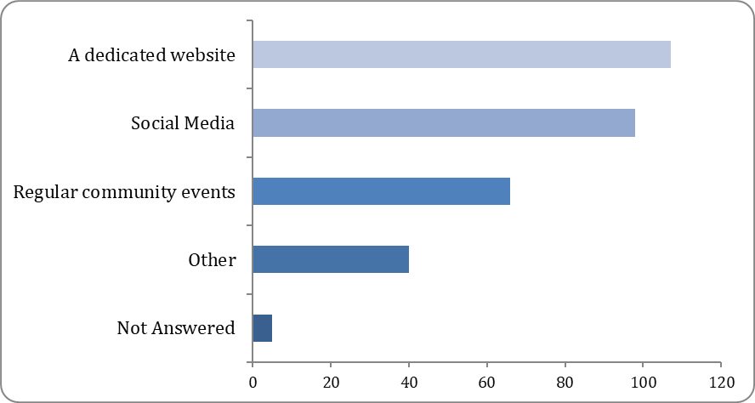
Option | Total | Percent
A dedicated website | 107 | 54.87%
Social Media | 98 | 50.26%
Regular community events | 66 | 33.85%
Other | 40 | 20.51%
Not Answered | 5 | 2.56%

There were 48 comments relating to Question 8. The majority of people responded with ‘emails’ or ‘newsletters’ and pointed to good examples such as the Reading Borough Council newsletter which was praised as an ‘excellent piece of communication’. A small number of people responded requesting direct/in person events and utilising community spaces, such as notice boards and hoardings.

