Domestic Abuse Strategy for Reading
2019 – 2022

Overseen by the Domestic Abuse Strategy Group
A sub-group of Reading’s Community Safety Partnership

DRAFT

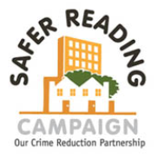

WHAT IS DOMESTIC ABUSE?
A coherent strategy that tackles domestic abuse effectively needs to be informed by an understanding of the various forms of domestic abuse.
Domestic abuse and domestic violence are terms used interchangeably by many organisations. However, in line with the Government definition below, this strategy will use the term ‘domestic abuse’, in order to encompass both violent and non-violent behaviours.
The draft Domestic Abuse Bill 2019 proposed statutory definition, defines domestic abuse as:
“Any incident or pattern of incidents of controlling, coercive, threatening behaviour, violence or abuse between those aged 16 or over who are, or have been, intimate partners or family members regardless of gender or sexual orientation. The abuse can encompass, but is not limited to:
• psychological
• physical
• sexual
• economic
• emotional
Controlling behaviour: Controlling behaviour defines acts designed to make a person subordinate and/or dependent by isolating them from sources of support, exploiting their resources and capacities for personal gain, depriving them of the means needed for independence, resistance and escape and regulating their everyday behaviour.
Coercive behaviour: Coercive behaviour is an act or a pattern of acts of assault, threats, humiliation and intimidation or other abuse that is used to harm, punish, or frighten their victim. The significance of this new definition is its intention to be underpinned by statutory guidance, and the rewording of financial abuse to economic.
While the definition outlined is not yet legal, it is used across all Government departments. One of the changes includes the replacement of ‘financial abuse’ with ‘economic abuse’, as part of the Government’s ‘expansive approach’ to recognising that “victims may be forced into taking out loans or entering into other financial contracts by [perpetrators]”. By changing the term in this way, wider forms of domestic abuse can be identified and addressed.
Forms of Domestic Abuse
All genders, and those that define as any sexuality, experience domestic abuse in a variety of forms. Domestic abuse can also occur between wider family members when they are living within the same household. In addition to the methods described in the above definition, other forms of domestic abuse include:

‘Harmful Cultural Practises’: Abuse in relation to:
- ‘Honour’ Based Abuse (HBA): Abuse committed to protect or defend the perceived ‘honour’ of a family and/or community, although not condoned by any cultural or religious belief. Young women are the most common targets, and become victims after deviating from their community’s boundaries of perceived acceptable feminine/sexual behaviour. Victims have been murdered in extreme cases of HBA.

- Forced Marriage: A marriage conducted without valid consent of one or both parties, where duress or lack of capacity is a factor. Please note that this is not to be confused with arranged marriages, where consent is indeed supplied.

Domestic Servitude: Domestic Servitude can occur in some instances of forced marriage, and involves victims being forced to perform all household tasks, including cooking, cleaning and child-care. They may work 10 to 16 hours a day, and are rarely allowed out of the house without a chaperone.
Inter-Familial Violence/Parental Abuse: Violence between adult family members.
Stalking: Repeated (i.e. on at least two occasions) harassment causing fear, alarm or distress. It can include threatening phone calls, texts or letters; damaging property; spying on and following a person.
Harassment: The term harassment is used to cover the 'causing alarm or distress' offences under section 2 of the Protection from Harassment Act 1997 as amended (PHA), and 'putting people in fear of violence' offences under section 4 of the PHA. The term can also include harassment by two or more defendants against an individual or harassment against more than one victim.
This strategy does not include our approach to reducing Female Genital Mutilation as this is covered within a separate work stream within Children’s Services. It also does not cover child to parent violence where the aggressor is under the age of 16.
NATIONAL CONTEXT
Tackling domestic abuse continues to be a national priority for the Government. In response, local authorities are expected to outline their approach to reducing the prevalence of domestic abuse in their areas, addressing the particular challenges presented by local demographics.
In 2016, the Home Office launched its ‘Violence Against Women and Girls Strategy (VAWG)’, which intends to transform the delivery of services, make prevention and early interventions the foundation of its approach, and embed an “everyone’s business” ethos across agencies, services and the wider public. The strategy reports that domestic violence costs the UK £15.8bn annually, and to meet the challenge the Government have pledged £80m of funding to provide ‘core support for refuges and other accommodation-based services’. Although a strategy aimed at addressing violence against women and girls, the principles of the strategy can also be applied to men, boys, and people that define as LGBT+.
Domestic Abuse in the Law
While a wide variety of behaviours defined as domestic abuse are universally recognised as destructive, not all such behaviours are illegal. While this situation is changing, it is important for the purposes of this strategy to recognise the current legal boundaries we must operate within.
In criminal law, domestic abuse is an umbrella term used to refer to a number of different offences against a family member or intimate partner, such as assault. Unfortunately, not all reports to the police can be recorded as a crime, such as verbal aggression towards a partner, and therefore get logged as a ‘non-recordable’ domestic abuse incident.
However, legislation around domestic abuse is changing. Recent updates include:
The Serious Crime Act 2015 by the Home Office, which criminalises patterns of coercive and controlling behaviour where they are perpetrated against an intimate partner or family member.
The Domestic Violence Disclosure Scheme, commonly known as Clare’s Law, which was introduced in 2012 by the Home Office. This development allows that police to disclose information about a partner’s previous history of violence under some circumstances, and where the risk to the victim can be identified as prevailing over the right to privacy of the partner.
The introduction of Domestic Violence Protection Notices (DVPNs) and Domestic Violence Protection Orders (DVPOs) in March 2014. These notices and orders were introduced to tackle situations where perpetrators are arrested, but not charged, and are thereby able to return directly to the location of the victim. Prior to these developments, there were no restraints on the perpetrator as bail conditions are not enforceable without an official charge. The DVPNs and DVPOs are designed to provide individuals with temporary respite (to a maximum of 48 hours and 28 days respectively) so that they can make decisions for the future, and potentially apply for a civil injunction, before the perpetrator is able to make contact.
Draft Domestic Abuse Bill - Central Government’s Violence Against Women and Girls Strategy 2016-2020, Victims Strategy 2018 and Female Offender Strategy 2018, provide the back drop for a significant review of the existing response to domestic abuse. In 2017 the Government launched a consultation called ‘Transforming the response to Domestic Abuse’ and in January 2019 the response to the consultation and draft Domestic Abuse Bill was published.
The document is based around four main objectives:
- Promote awareness – to put domestic abuse at the top of everyone’s agenda, and raise public and professionals’ awareness.

- Protect and support – to enhance the safety of victims and the support they receive.

- Pursue and deter – to provide an effective response to perpetrators from initial agency response through to conviction and management of offenders, including rehabilitation.

- Improve performance – to drive consistency and better performance in the response to domestic abuse across all local areas, agencies and sectors.

Other legislation that impacts on the development of this strategy is the Children and Social Work Act 2017 and associated regulations which require relationships and sex education to be taught in all English schools from September 2020.

PREVELANCE
It is the responsibility of all Local Authorities and partners to tackle Domestic abuse and protect local residents from harm. Reading’s Community Safety Partnership places value in collaborative working across organisations to collect data and plan strategic approaches.
Police reports
The national picture identifies high levels of domestic abuse around the country. The police recorded 599,549 domestic abuse-related crimes in the year ending March 2018, and 598,545 non-crime incidents reported to the police. This was an increase of 23% from the previous year. This in part reflects police forces improving their identification and recording of domestic abuse incidents as crimes and an increased willingness by victims to come forward. However this doesn’t show the full picture, as the Crime Survey for England and Wales show little change to previous years, with 2 million adults aged between 16-59 reporting that they have experienced domestic abuse in the same period (65% women, 35% men).
In Reading there has also been a significant increase in crimes reported in the last year also partly reflecting both a national and local change in practice within the police.
Thames Valley Police Recording | 2014/15 | 2015/16 | 2016/17 | 2017/18 | 2018/19
Domestic Abuse Incidents: Recorded Crime | 1086 | 1240 | 1171 | 1082 | 1547
Domestic Abuse Incidents: Non-Crime Occurrence | 1,271 | 1,102 | 1,380 | 963 | 732
Total | 2,357 | 2,342 | 2,551 | 2,045 | 2,279

Domestic Abuse Incidents in Reading:
The graph below shows the same data and highlights that although the total number of incidents is 13% lower than 5 years ago, there has been a significant increase in crimes recorded (42%).

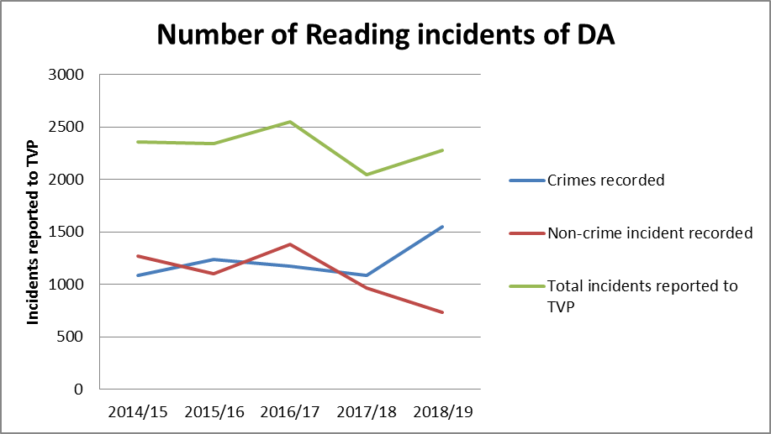
Thames Valley Police recorded and non-recorded crime 2019.
To provide further context the number of crimes recorded per 1000 population during 18/19 is compared to the figure in other major towns in the Thames Valley, the TV average and national average.
 | Crimes per 1,000 Households recorded in 18/19
Thames Valley Police Recording | Reading |  | Oxford |  | Slough |  | Thames Valley |  | National
Year | 17/18 | 18/19 | 17/18 | 18/19 | 17/18 | 18/19 | 17/18 | 18/19 | 17/18 | TBC
Domestic Abuse Incidents: Recorded Crime | 6.14 | 9.51 | 5.07 | 7.02 | 9.05 | 11.2 | 4.71 | 6.83 | 10
Domestic Abuse Incidents: Non-Crime Occurrence | 5.86 | 4.5 | 4.95 | 3.18 | 9.36 | 5.29 | 5.58 | 3.66 | 10
Total | 12 | 14.01 | 10.02 | 10.2 | 18.41 | 16.49 | 10.29 | 11.49 | 20

The table above indicates that Reading is experiencing levels of domestic abuse above the Thames Valley average for both recorded and non-recorded crime. This is to be expected as an urban area and is only slightly above the other urban centres in the Thames Valley. However all of the Thames Valley, including Reading, remain significantly below the average for England and Wales.
Domestic abuse consistently represents c.10% of all crimes reported to the police within the Reading area. This matches the Thames Valley and compares to 12% for England and Wales.
DOMESTIC ABUSE STRATEGY FOR READING 2015-18
In 2015 Reading Community Safety Partnership published a three year Domestic Abuse Strategy for Reading which set out the following priorities:
- Encouraging people to seek support earlier - Improving information, education and prevention.
- Providing the right response first time - Improving identification, encouraging disclosures and ensuring an appropriate immediate response.
- Having the right services available - Improving support to move from victim to survivor or to change abusive behaviour.
- Understanding of the challenges in our town - improving data analysis and community engagement.
This strategy has been successfully delivered by the Community Safety Partnership as summarised below.
Procurement
A key driver in the 2015-19 Strategy, impacting on all strands of strategic delivery was the requirement to recommission all domestic abuse support services in the town, including support within refuge provision. After an extensive review of current and projected needs this procurement was completed with two new contracts implemented in October 2017, which will remain in place for the life of this updated strategy, 2019 - 22. One contract (£90,000 p.a.) funds the support provided to 15 refuge spaces located in the town (4 specialist spaces for women from the Asian community) and a wider contract (£255,000 p.a.) funds a range of services from providing training for the Reading workforce on domestic abuse; delivering support at the point of crisis; and supporting those who both experience and perpetrate abuse to break the cycle of abuse. A local domestic abuse charity, BWA, deliver both these contracts.
Priority 1 - Encouraging people to seek support earlier - Improving information, education and prevention.
Increasing professional and public knowledge on the subject of domestic abuse will make it easier for those who are experiencing abuse to access support and broadens their opportunities to do this as early as possible. It will also enable people to make more informed judgements regarding their relationships.
Actions completed:
- Improvements to both the Council’s and partners’ websites have been completed and Police-led awareness raising campaigns have been supported.

- BWA have delivered 33 training course and trained 579 front line staff on domestic abuse (level 1 and 2), and continue to deliver 10 days of training per year

- Training sub-group of the Domestic Abuse Strategy Group has reviewed the training to ensure that it remains relevant and up to date. The training continues to receive positive feedback. Of the 88 people that attended level 1 training, 47% rated it as excellent and 47% as good, and of the 70 people that attended level 2 training, 63% rated it as excellent and 34% as good. Combined candidates stated that (on a scale of 1-10) their confidence and knowledge had improved by an average 2.8 points.

- As set out in the 2015-18 strategy, Domestic Abuse forums to promote professional development of staff across agencies were re-introduced in 2016 and delivered quarterly. The forums have proven to be extremely popular with between 50-80 staff in attendance at each session, providing training on a specific topic followed by a wider group discussion. The topics have included:
  - ‘Why don’t they just leave?’
  - The impact of domestic abuse/ trauma on child development
  - Victimless prosecutions
  - Stalking and Harassment
These forums will remain a key part of our staff development and engagement programme moving forward.

- Introduced an online training programme focusing on DA within LGBT+ relationships.

- Programme to encourage reporting/ appropriate recording of incidents of domestic abuse towards adults with a disability.

Outcomes:
- Increased referrals to the MARAC (58% increase since 2015)

- Increased MARAC referrals involving adults with a disability (from 0 – 11% since 2015), reflecting better recognition and recording of incidents.

- Increased use of support agencies with clear referral routes.

Further action required:
The partnership has made limited progress in promoting and ensuring a consistent educational offer around healthy relationships for young people in schools and other settings. Supported by the recent change in Government legislation this remains a focus of the refreshed strategy, and is a shared priority with the Berkshire West Safeguarding Children Partnership (previously the Local Safeguarding Children’s Board).

Outcome in focus: Increased referrals to the Multi Agency Risk Assessment Conference (MARAC)

Multi-Agency Risk Assessment Conferences (MARACs) are regular local meetings where information about high risk domestic abuse victims (those at risk of serious harm) is shared between local agencies. By bringing agencies together at a MARAC and ensuring that whenever possible the voice of the individual experiencing abuse is represented, a risk focused, co-ordinated safety plan can be drawn up to support the individual.

The Reading MARAC, chaired by Thames Valley Police, aims to review and co-ordinate service provision where the victim is assessed as being at high risk of harm.
Key actions in the previous strategy were to:
- Increase referrals to the MARAC to a minimum of 80% of the Safelives target (of 40 referrals per 10,000 population, which equates to 200 cases a year and 34 per 100,000 female population).

- Increase the referrals from partner agencies other than the Police to within the Safelives target (25-40%). This helps ensure that high risk cases that have not contacted the police have access to the additional safety planning at the MARAC.

- Increasing referrals from people who define as LGBT+ and where the person experiencing abuse has a disability to be in line with the SafelIves target (5% and 17% respectively).

The graph below shows the referrals to MARAC per 100,000 female population since 2014.

The graph above shows that apart from a small dip mid 2018, the MARAC (high risk) referrals increased to above the Reading strategic target in June 2016 and have remained there since.

The Reading MARAC has seen increases in cases over the past three years for victims with disabilities and from residents who define as LGBT+. Reading is above both the Thames Valley and National reporting levels, highlighting the work that has been done in the area to target under-represented groups. Strategic partners of DASG believe the increase in referrals from these groups can be attributed to improved reporting opportunities and increased training and awareness. Both areas are still below the Safelives target, however, the trend for referrals relating to an adult with a disability indicates significant progress in this area (increased from 0- 11%). The trend for referrals from victims that define as LGBT+ is less encouraging and therefore this will remain a focus for the separate but connected MARAC action plan.

Priority 2- Providing the right response first time - Improving identification, encouraging disclosures and ensuring an appropriate immediate response.
Actions completed:
- Delivered a bespoke MARAC training package for Designated MARAC officers.

- In order to ensure the continued effectiveness of the Reading MARAC, the partnership welcomed an audit of practice by BWA in 2017/18. Actions are contained with the MARAC improvement plan.

- Introduced new contract arrangements that enable the local support agency to attend the Children’s Single Point of Contact/ MASH on a daily basis (2 hours a day).

- Published referral pathways to support agencies/Police services

- Improved local safeguarding training in relation to DA

- Specialist training for GPs delivered with over 40 GPs attending.

Outcomes:
- Professionals across agencies are equipped to notice the signs of and encourage disclosures of domestic abuse – Reading consistently remains above the SafeLives target in terms of MARAC referrals from partner agencies.

- Increased partnership work between support services and Children’s Services, now Brighter Futures for Children.

- Clear referral pathways between GP’s and support services, with an average of 2 referrals a quarter.

Further action required:
There remains to be limited referrals to support agencies and the MARAC from people within the LGBT+ relationships.

Outcome in Focus: Increased partnership work with Brighter Futures for Children

Children who live with domestic abuse are likely to feel that impact all their lives. Not only can the impact of trauma significantly impact the development of young children, there is increased risk of children becoming victims of abuse themselves, an ever-increasing harm to the child’s physical, emotional and social development and a strong likelihood that this will become a continuing cycle of violence for the next generation.^{[1]} Recognising the high number of Children’s Safeguarding Cases where domestic abuse was a concern, there was a focus on improving how children are supported where there is domestic abuse in the home.

The procurement exercise completed in 2017 ensured that commissioned services were able to continue to support children and young people, predominantly in a school setting. It also introduced the requirement for BWA to spend two hours a day minimum within the Children’s Single Point of Contact office, supporting social care to triage domestic abuse cases and to provide information to the Multi-Agency Safeguarding Hub.

In late 2018, Reading Borough Council announced the launch of a new children’s services company for Reading, called Brighter Futures for Children (BFFC). The company is wholly owned by, but independent from, Reading Borough Council. The Domestic Abuse Strategy Group will ensure that essential relationships are maintained and built with the staff in this company, in order to continue the collaborative approach to tackling domestic abuse.

Priority 3 - Having the right services available – Improving support to move from victim to survivor or to change offending behaviour.
A key focus of the previous strategy was to reduce repeat incidents of domestic abuse delivered via three key strands through commissioned services:
Actions completed:
- Services requirements review as part of the procurement of new services resulting in an increased focus in non-accommodation based support, whilst refuge spaces supported remain above average.

- DARIM (Domestic Abuse Repeat Incident Meetings) introduced and embedded.

- Supported the implementation of the Troubled Families Programme.

- Support for people who experience domestic abuse increased via funding from the Police and Crime Commissioners Office.

- Promoted the use of the Sanctuary Scheme to support households who choose to remain in their own home

- The Council has adopted a more proactive approach to early intervention and prevention approach to Homelessness and is able to rapidly facilitate access to private rented sector accommodation; including offering financial assistance where needed with deposits and rent in advance. The Council is no longer placing families in Bed and Breakfast even where an emergency placement is required.

- Choices and self-esteem programme continued and supported 240 people in the financial year 2018-19.

- Perpetrator programme supported c.50 people per year to understand and reduce their offending behaviour.

Outcomes:
- Improved coordination of high-risk cases and cases with multiple incidents.

- Comprehensive support provided for those that have experienced domestic abuse who wish to seek alternative accommodation or remain in their own homes.

- Appropriate services remain available to both those experiencing and those that are perpetrators of domestic abuse in order to reduce incidents.

Further action required:
Support for people that report incidents to the police and pursue them through the criminal justice system still needs to be reviewed and increased. This is critical to increasing the number of successful police and court outcomes.

Outcome in focus: Use of support services

A key objective of the previous Domestic Abuse Strategy was to ensure that appropriate services were available in Reading at the point of crisis and to break the cycle of abuse. The recent procurement of new domestic abuse services enabled the partnership to shape the nature and focus of that support. Alongside support at 15 refuge places, the services now provided by BWA include those listed below:
- Helpline: A 24 hour helpline run by BWA for anyone seeking information and support.
- Drop in Service: BWA provide an accessible safe venue for members of the public to ‘drop in’. The service offers face-to-face support and access to BWA and external support services.
- Outreach Support: BWA provide 1:1 support for people experiencing abuse which includes safety and support planning, and support to access other services such as housing, legal and the criminal justice system.
- Choices and self-esteem sessions: These are predominately provided within a group environment to those who have experienced abuse.
- Support to children and young people: Direct support for children, predominantly within the school setting, who have been living in a household where there is domestic abuse.
- Perpetrator programme: Support to perpetrators to decrease their abusive behaviour.

The table below shows the demand for helpline and outreach services in Reading over the last 5 years:
Service | 14/15 | 15/16 | 16/17 | 17/18 | 18/19
Helpline | 1,702 | 2,697 | 3,239 | 2,695 | 2,266
Outreach Support | 363 | 464 | 597 | 454 | 469

86% of the calls to the helpline are consistently only for information rather than requiring any further referrals This indicates that it is a key tool in enabling those experiencing abuse, or their friends and family, to increase their knowledge of the options available to them and make informed decisions regarding their future. 14% of the calls are referred to other BWA services – from outreach support through to refuge provision.

Outreach support is still BWA’s most pressurised service area and partners remain committed to ensuring that only appropriate referrals are submitted. Currently c45% of referrals are self-referrals, 43% of clients are still in a relationship with the perpetrator and the breakdown of risk across all referrals is as follows:
- High risk – 38%
- Medium risk – 20%
- Standard risk – 23%
- Unknown – 19%

165 clients were seen at the drop-in service this year.

109 clients attended the Choices or Self –Esteem course during the financial year 20/18-19 and user feedback of the support sessions remains extremely positive. In 2018/19 100% of those that completed the courses stated that they found them useful and, critically, that they felt safer as a result of it.

It is harder to assess the impact of the support for children and young people (193 engaged with BWA) but 75% of those that completed the course showed an improvement to the question “Do you know what to do when you feel worried/scared/unsure?”

55 perpetrators of domestic abuse worked with BWA during 2018-19, but the outcomes of the perpetrator programme are more difficult to establish. A focus of this strategy is to build on the work of BWA and increase the engagement activity of all agencies with perpetrators of domestic abuse.

BWA also deliver a Thames Valley-wide project funded by the office of the Police and Crime Commissioner to provide additional support for clients with mental health issues, and a separate project to provide specialist support for women from BAMER (Black, Asian, Minority Ethnic and Refugee) communities.

These services will remain in place for the lifetime of this strategy and remain part of the partnership’s key response to supporting those who are experiencing abuse.

Priority 4 - Understanding of the challenges in our town - improving data analysis and community engagement.
Actions completed:
- Data dashboard created and reviewed regularly by Strategy Group

- Prevalence of forced marriage recorded

- DA data published within JSNA

- Stalking and Harassment featured as a focus within Domestic Abuse Forum.

- Successful bid to MHCLG (then DCLG) to obtain funding to support a Thames Valley wide BAMER project.

Outcomes:
- Data now supports evidence based decision making

- Increased awareness of Stalking and Harassment

Further action required:
A consultation with people who define as LGBT+ to ensure services are inclusive and accessible is still to be completed.
Outcome in Focus: Successful bid for funding to support the Thames Valley wide BAMER project

In 2017 Officers at Reading Borough Council successfully bid, in consultation with of the Office of the Police and Crime Commissioner and other Local Authorities in the Thames Valley, to the then DCLG to fund the support at four refuge spaces of specialist provision for women from the Asian community (for two years). This was in addition to the four spaces funded by Reading Borough Council as part of the recently award contract to BWA. These 8 refuges spaces in Reading remain the only specialist units within the Thames Valley.

The proposal also requested funding for an additional post to provide advice and support to other refuges and outreach workers/ IDVAs throughout the area, and a strategic resource to review current services and increase the understanding of what individual communities may require in terms of specialist resource throughout the Thames Valley. Both roles would be additional resources in the area.

In parallel, the Office of the Police and Crime Commissioner were again successful in bidding for Home Office funding for a similar proposal that would be completed in other areas of the Thames Valley. Therefore it was agreed that the two pots of money would be combined and an all-inclusive Thame Valley wide BAMER project was created.

This project is governed by the TV BAMER board chaired by the Office of the Police and Crime Commissioner, and due to the efficient use of money is able to fund the following:
- 4 units of specialist Asian refuge provision delivered by BWA
- 6 specialist BAMER outreach and engagement workers across the Thames Valley – West of Berkshire post delivered by BWA
- 1 strategic post to review resources, consult with communities to fully understand the needs of marginalised groups within the Thames Valley and inform future commissioning.

STRATEGIC PRIORITIES 2019-22
Many of the actions and improvements set out in the 2015-18 strategy have now become ‘business as usual’ for professionals working in Reading. The Domestic Abuse Strategy for Reading 2019-22 looks to build on this and focuses on four priority areas:
Priority 1 –Raising awareness about domestic abuse with a focus on:
- Workforce Development – Continue to ensure a knowledgeable and well trained workforce.

- Healthy Relationship Education – increasing the resilience of Young People to negative relationships and behaviour.

- Engagement with marginalised communities - Encouraging those experiencing abuse to seek help at an earlier stage

Priority 2: Developing a multi-agency approach to working with perpetrators – Working with strategic partners to create a perpetrator approach to reduce and prevent repeat domestic abuse, including increasing the number of cases that progress through the criminal justice system.
Priority 3 – Improving our partnership response to Coercive Control –Training professionals to understand and identify coercive control, so as to increase and better manage disclosures.

Priority 1 –Raising awareness about domestic abuse with a focus on:
a) Workforce Development – Continue to ensure a knowledgeable and well trained workforce.
All front line services across Reading Borough Council and partner agencies have the potential to interact with someone experiencing domestic abuse. The Community Safety Partnership is committed to making sure that people in Reading get the right response first time from professionals, and that it does not take the average five contacts with services that national research suggests. Effective training to notice the signs of domestic abuse and respond appropriately will mean that more domestic abuse concerns are resolved at an earlier stage and the impact on those experiencing it and their children will reduce.
Ensuring that all areas of the workforce have an understanding of domestic abuse and are aware of the referral pathways is critical to enabling an effective response. Significant improvements have been made during the previous strategy and these activities will continue. The focus now will be in working with targeted teams across the partnership to increase the training take up, and developing mechanisms to allow a consistent level of training and understanding.
This strand will be led by the training sub-group of the Domestic Abuse Strategy Group.
b) Healthy Relationship Education – increasing the resilience of Young People to negative relationships and behaviour.
In recent years, there has been both a national and local identification of unhealthy teenage relationships. While this may be due to a variety of factors, such as increasing mental health diagnoses or exposure to Adverse Childhood Experiences (ACEs), the Reading Community Safety Partnership is committed to addressing unhealthy behaviours so that young people are prevented from becoming both perpetrators and victims of domestic abuse.
When designing actions to implement a Healthy Relationship Programme, a steer will be taken from the draft statutory ‘Relationships Education, Relationships and Sex Education (RSE) and Health Education guidance’ and all ideas for the best approach will be considered. These include:
- Starting the programme in both primary and secondary schools, in order to implement healthy relationship awareness from a young age and prevent harmful behaviours.

- Tackling low self-esteem in both a general and domestic abuse context, following identification of this being a factor that can make a young person more vulnerable to perpetrating and experiencing domestic abuse.

- Ensure the approach and delivery of Healthy Relationship Education in PSHE lessons is consistent across all schools.

- Ensure schools are equipped to receive an increase in disclosures if the programme is successful.

- Ensure that young people not in school have access to this education.

This stream of work will be delivered by the ‘Adolescent Risk’ strand of the One Reading Prevention and Early Intervention Partnership.
c) Engagement with marginalised communities - Encouraging those experiencing abuse to seek help at an earlier stage
Referrals to the MARAC relating to Black and Minority Ethnic (BME) women has remained at between 40%-45% throughout the term of the previous strategy. This is higher than the estimated BME population of Reading, meaning that BME women are disproportionately represented at the MARAC. At the same time, BME women are significantly under-represented in take-up of preventative and support services provided in the town. Reading is participating in a Thames Valley-wide project researching the needs of BME women experiencing abuse. The project is chaired by the Office of the Police and Crime Commissioner, which is focused on increasing support for these communities. The findings of this work will inform the further development of this strategy.
As highlighted above, under representation within those accessing support or being referred to the MARAC of people who define as LGBT+ continues to be a concern. This strategy will progress the consultation programme previous outlined to increase the partnership’s understanding of any barriers to accessing services people are experiencing.
This strand will be led by the Training sub-group of the Domestic Abuse Strategy Group
Target Outcomes:
- Increase the take up of level 1 and 2 Domestic Abuse training to ensure all areas of the workforce are aware of the resources.

- Increase the confidence of the workforce in completing DASH assessments

- An increase in the number of young people with an understanding of healthy relationships.

- Increased referrals to the support services from BAMER communities.

- Increase in referrals to support services and MARAC for LGBT+ relationships.

Priority 2: Developing a multi-agency approach to working with perpetrators – Working with strategic partners to create a perpetrator approach to reduce and prevent repeat domestic abuse, including increasing the number of cases that progress through the criminal justice system.
Perpetrator Profiling
BWA offer a Perpetrator Programme, and have a range of demographic data similar to that collected for victims. Of the 68 new perpetrators they worked with between April 2017 and March 2018, 97% were male. This profile only represents the perpetrators that access the BWA programme.
Almost half of perpetrators were between 25 and 34:
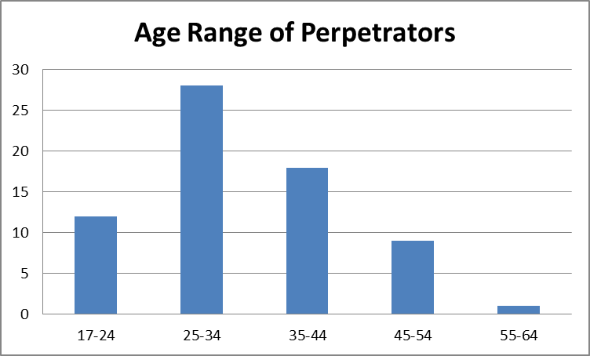

Over half of perpetrators were White British:

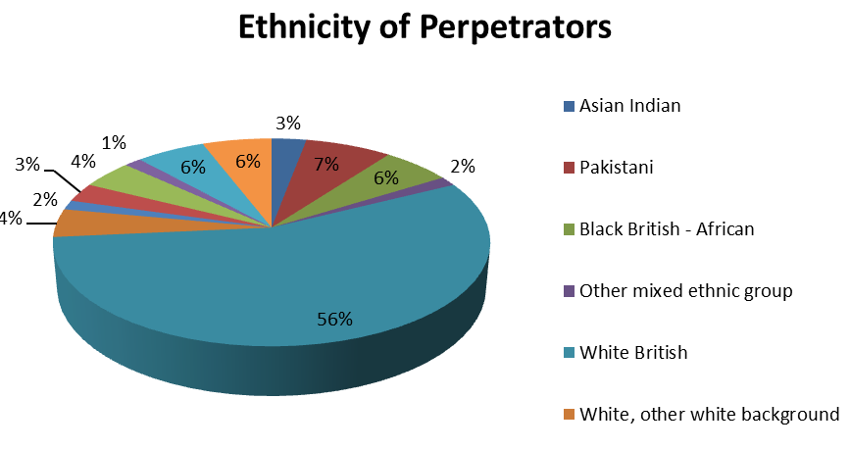

Over half were in full-time employment:
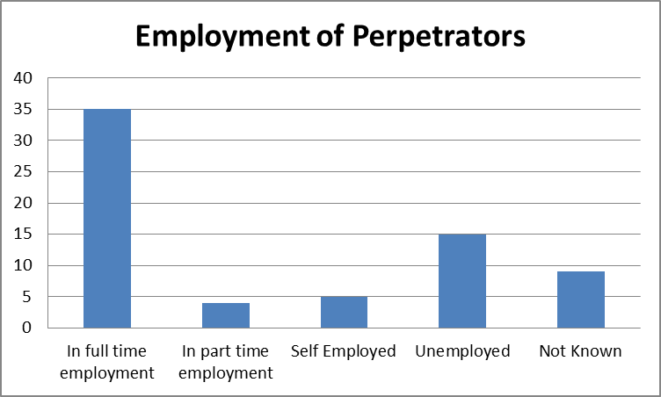

The profile indicates that the most common types of perpetrators are young men, white British Males, employed, and have underlying issues such as substance misuse (60%). While this profile is generated based on those involved in BWA’s Perpetrator Programme, it provides useful insight into the types of domestic abuse perpetrators in Reading.
The Government’s Domestic Abuse Bill consultation in May 2018 provided partners with an opportunity to think creatively about how they would work with perpetrators.
It was agreed that the focus will be on implementing an improved local Integrated Offender Management (IOM) programme. The IOM is a national and local programme that brings a cross-agency response to the crime and reoffending threats faced by local communities. The most persistent and problematic offenders are identified and managed jointly by partner agencies working together.
IOM helps to improve the quality of life in communities by:
- Reducing the negative impact of crime and reoffending

- reducing the number of people who become victims of crime

- helping to improve the public’s confidence in the criminal justice system

A recent report highlighted that only 6 of the 30 perpetrators in the IOM system were perpetrators of domestic abuse. This figure is below the force average across Thames Valley, and due to the prevalence of domestic abuse nationally this figure should be higher. It has therefore been decided that more involvement from partner agencies is needed in the management of domestic abuse perpetrators.
The Multi-Agency approach will be essential for sharing intelligence and increasing the number of offenders on the IOM programme; targeting perpetrators who have not yet been criminalised and who therefore cannot be included in IOM; determining the type of intervention programmes to put perpetrators are linked in with; and monitoring the actions of perpetrators before, during and after interventions in order to evaluate the programmes’ impact.
The IOM approach will be supported by the introduction of the Multi Agency Tasking and Coordination (MATAC) meeting which will replace the DARIM and be delivered alongside the MARAC. The MATAC will be chaired by Thames Valley Police but will be a multi-agency conference with the objective of reducing the risk behaviour of high risk and high volume perpetrators.
Part of the IOM approach includes the disruption of perpetrator behaviour with interventions from the police and criminal justice system.
Improving successful outcomes for identified crimes is a priority, as is increasing alternative police interventions including, but not limited to, Domestic Abuse Protection Notices and Orders and implementing Clare’s Law.
This intention is further supported by the Thames Valley Police Strategic Plan 2019/20 which includes a focus on domestic abuse including stalking and harassment, and has the following targets:
• An improvement in how quickly domestic abuse incidents are attended.
• An improvement in the arrest rate for attended domestic abuse crimes.
• An increase in the use of DVPNs/DVPOs.
• An increase in the volume of domestic abuse crimes that lead to a positive outcome.
• Consistently effective investigations into stalking and harassment offences.
Successful police intervention will be more effective when linked with the parallel support for victims. Therefore it is necessary to have a clear pathway regarding referrals, and an increase in support to people when a victim/ witness of domestic abuse.
The increase in police outcomes should be supported by an improvement in Court outcomes. In 2017/18, 2,399 domestic violence cases were brought to Thames Valley courts; 958 of which took place in Berkshire specifically. The number of cases taken to court across Thames Valley has increased by 214% (713) since 2013/14. This increase is aligned with the national picture.
The number of successful and unsuccessful cases is detailed below:
 | No. of cases brought to court | No. of successful cases | % of successful cases | No. of unsuccessful cases | % of unsuccessful cases
Thames Valley | 2,399 | 1,832 | 76.4% | 567 | 23.6%
Berkshire | 958 | 725 | 75.7% | 233 | 24.3%

As outlined, both Berkshire and Thames Valley have similar outcome rates. Of the 233 unsuccessful cases in Berkshire, 11.6% (27) were due to Evidential Issues that prevented the case from proceeding and 52.8% (123) were due to Victim Issues. The same analysis of Thames Valley shows that of the 567 unsuccessful cases, 9.2% (52) were due to Evidential Issues and 53.4% (303) were due to Victim Issues.
Overall, both Berkshire and Thames Valley have made positive improvements in the number of cases taken to court and successful outcomes. While the number of unsuccessful cases is proportionally low, 50% are due to Victim Issues, which suggests that more support is needed for victims within the court process, so that they pursue their case through to completion.
This strand will be led by the perpetrator sub-group of the Domestic Abuse Strategy Group.
Target Outcomes:
- The delivery of a cohesive action plan that outlines how various strategic partners will collaborate to tackle perpetrators of domestic abuse.

- Implementation of an Integrated Offender Management approach to domestic abuse perpetrators.

- Improved monitoring of perpetrators.

- Increase in positive police outcomes for domestic abuse Cases.

- Increased use of Domestic Violence/ Abuse Protection Notices and Orders, including in cases of coercive control.

- Increased use of the Domestic Violence Disclosure scheme (Clare’s Law)

- A mapped and utilised pathway in to support for victims engaging with the Criminal Justice System.

Priority 3 – Improving our partnership response to Coercive Control –Training professionals to understand and identify coercive control, so as to increase and better manage disclosures.
Since 2015, Thames Valley Police have recorded 316 instances of coercive control; only 36 of which were in Reading. Considering both the commonality of coercive control in cases of domestic abuse and the statutory guidance underpinning its identification, the outlined figure is significantly low. The impact of coercive control and psychological abuse cannot be understated, with 94% of victims citing mental health cruelty as more painful to endure than physical violence.
Mirroring other organisations in the South-East, Thames Valley Police has faced the challenge of reduced funding and staffing changes, with many long-standing officers retiring and a younger cohort of officers needing training. It is important that the TVP workforce recognise cases of Coercive Control and ensure that appropriate actions are completed and police outcomes are obtained.
Another factor in low recording of coercive control is its low identification by professionals, even when a DASH form is completed. This suggests that one of the main issues is a lack of training in this area. The Domestic Abuse Training Team has and is continuing to work with GPs and Royal Berkshire Hospital to provide training in Domestic Abuse. However, as coercive control reporting levels are low, training will remain a priority in order to build confidence in professionals to identify and report identified cases.
Improvements to recording incidents within the Police have already started. Previously where multiple crimes are reported at once, only the most serious crime was recorded on the system and then all investigated together. However more recently the recording rules have changed and Coercive Control is always record as a separate occurrence and linked to other crimes that may also have occurred. This will meant that we should see an increase of reports as they’re being recorded accurately and separately.
As safeguarding agencies, Domestic Abuse Strategy Group partners have the responsibility to train the public in identifying coercive control so that they can refer themselves and stay safe. Training for professionals is therefore the first action of a two-part plan to train and stabilise coercive control identification, before running an awareness campaign to increase referrals. By focusing on professionals first, the safeguarding sector will be able to efficiently and confidently receive disclosures and provide victims with effective support.
In conjunction with Priority 2, DASG will also aim to improve recording of coercive control and use the multi-agency approach of sharing intelligence to increase the number of coercive control cases taken to court. By requesting evidence collected by partners, the Police can better shape their prosecutions and better record cases of coercive control where the victim does not want to be involved in legal proceedings.
The following case study indicates that coercive control cases can certainly achieve convictions:
Case Study:
“Mr A was sentenced for offences against his ex-partner Ms B. He was convicted and sentenced on 08.10.2018 for coercive and controlling behaviour within an intimate relationship between 16/05/18-13/08/18. This conviction is to encompass all the offences against Ms B which include 7 other charges of Assault by beating x 5, Criminal Damage & ABH – these were to lie on file as he pleaded not guilty.
Mr A was sentenced to 2 years & 2 months imprisonment, 20 year Restraining Order made for Ms B, victim surcharge £170.
Mr A has had 15 offences of a domestic abuse nature since 2000 and he poses a high Risk of Serious Harm to partners and known adults whom he enters into a relationship with, through abuse, controlling behaviour and violence. Joint working over a period of time with the Police and National Probation Service ensured clear evidence was given to the Court for sentencing under the new legislation of coercive control. Evidence was gathered without the assistance of the victim, who was still under the effects of coercive control and afraid to act against the perpetrator. This is the theme of many of these cases – the perpetrator instils fear into the victim so that they are afraid for their life to leave them.”
By creating a collective understanding of coercive control and improving recording, more convictions like these can be achieved.
This strand will be led by the Coercive Control Sub-group of the Domestic Abuse sub-group.
Target Outcomes:
- Professionals in a variety of sectors/specialisms understand how coercive control works and how they can identify it.

- Build confidence in the referral pathway, so that in the future an awareness campaign can be rolled out to increase coercive control disclosures.

- In coordination with Priority 2, create an intelligence network to share information about cases that involve coercive control.

- Thames Valley Police receive more referrals and record more cases of coercive control.

- Thames Valley Police will have built relationships with partners, in order to request information and evidence to form cases against perpetrators of coercive control.

- Increase number of police outcomes in cases of Coercive Control

Implementation and Governance
Having clearly outlined our strategic priorities and target outcomes, the delivery of the strategy will be achieved through an associated action plan. When implemented effectively, the Community Safety Partnership’s Domestic Abuse Strategy for Reading will ensure those who experience domestic abuse can access the support they need for a safer life and more secure future.
The action plan which accompanies this strategy will be implemented by the Domestic Abuse Strategy Group. The Strategy’s progress will be regularly reported to the CSP.
Accountability
The structure chart below illustrates the governance of the strategic approach to domestic abuse in Reading.
Housing, Neighbourhoods and Leisure Committee
Local Children’s Safeguarding Board
Coercion and Control Working Group
Domestic Abuse Forum
Perpetrator Working Group
Training Sub-Group
MARAC
Domestic Abuse Strategy Group/ MARAC Steering Group
Safeguarding Adults Board
Community Safety Partnership
Adult Social Care, Children’s Services and Education Committee
As well as touching many lives throughout the town, the Domestic Abuse Strategy for Reading will also complement other key strategies aiming to improve day-to-day life for residents. These include:
Sustainable Communities Strategy for Reading
The Domestic Abuse Strategy for Reading directly aligns with the Reading 2030 vision of ensuring residents feel comfortable, safe, secure, and well-housed. The service empowers those experiencing abuse to find safety and security from perpetrators, thereby increasing the amount of choice and control they have over their lives.
Community Safety Partnership
The priorities within the Community Safety Partnership’s 2019-2022 Strategy are Violent Crime, Modern Day Slavery, and Drugs. The Domestic Abuse Strategy Group is one of five partnership delivery groups which report into the CSP.
Reading Borough Council Corporate Plan
The service priorities of Reading Borough Council’s 2018-21 Corporate Plan outlines the Authority’s commitment to “Protecting and enhancing the lives of vulnerable adults and children”. This priority directly aligns with the goals of the Domestic Abuse Strategy for Reading.
Berkshire West Safeguarding Children Partnership Action Plan
Domestic abuse remains a key focus for the Berkshire West Safeguarding Children Partnership.
Multi-Agency Domestic Abuse Pathway
Multi-Agency Domestic Abuse Pathway for new referrals (cases which are not open to Children Social Care – Brighter Futures) which will be integrated into the Childrens Single Point of Access and where appropriate the daily MASH meetings. These are regular local meetings where information about standard and medium risk domestic abuse families is shared between local agencies and multi-agency agreement. By bringing all agencies together and ensuring that wherever possible the voice of the child is represented and a risk focused outcome is achieved.
West of Berkshire Safeguarding Adults Board
The West of Berkshire Adult Safeguarding Board is in the process of developing their Strategy for Safeguarding Adults in the West of Berkshire 2018-2021.
Reading Borough Council’s actions, as outlined in this strategy, supports the commitment made by the West of Berkshire Adult Safeguarding Board and will work in partnership with them to help vulnerable adults live free from domestic abuse.

Gov.uk, Transforming the Response to Domestic Abuse Consultation Response and Draft Bill. https://www.gov.uk/government/publications/domestic-abuse-consultation-response-and-draft-bill (accessed June 2019)
Ibid
Gov.uk, Violence against women and girls (2016). https://www.gov.uk/government/publications/strategy-to-end-violence-against-women-and-girls-2016-to-2020
Ibid
Lesbian, Gay, Bisexual and Trans, plus other identities considered to fall under this umbrella, including but not limited to queer/ questioning, Intersex, Asexual, Pansexual
Gov.uk, Violence against women and girls (2016) https://www.gov.uk/government/publications/strategy-to-end-violence-against-women-and-girls-2016-to-2020
Gov.uk,Victim Strategy (2018) https://www.gov.uk/government/publications/victims-strategy
Gov.uk, Female Offender Strategy (2018) https://www.gov.uk/government/publications/female-offender-strategy
Gov.uk, Draft Domestic Abuse Bill May 2019. https://www.gov.uk/government/publications/domestic-abuse-consultation-response-and-draft-bill (accessed June 2019)
Children’s and Social Work Act 2017 http://www.legislation.gov.uk/ukpga/2017/16/contents/enacted (accessed June 2019)
Draft Relationships Education, Relationships and Sex Education and Health Education (England) Regulations 2019 http://www.legislation.gov.uk/ukdsi/2019/9780111181997 (accessed June 2019)
ONS, domestic abuse in England and Wales: year ending March 2018, November 2018.
A non-recordable incident of domestic abuse is not regarded as an offence and does not contribute to Home Office statistics. Recordable incidents of domestic abuse are those considered pursuable as an offence.
SafeLives is a national charity dedicated to ending domestic abuse - http://www.safelives.org.uk/ (accessed June 2019)
[1] Unicef -Behind Closed Doors The Impact of Domestic Violence on Children (2006)
Parliement.uk Outline of Adverse Childhood Experiences (ACEs), https://publications.parliament.uk/pa/cm201719/cmselect/cmsctech/506/50605.htm (accessed June 2019)
DfE, Relationships Education, Relationships and Sex Education (RSE) and Health Education guidance’ (2019) https://assets.publishing.service.gov.uk/government/uploads/system/uploads/attachment_data/file/781150/Draft_guidance_Relationships_Education__Relationships_and_Sex_Education__RSE__and_Health_Education2.pdf
Domestic Abuse Stalking and Harassment Risk Assessments
Gov.uk, ‘Integrated Offender Management’, https://www.gov.uk/guidance/integrated-offender-management-iom (accessed June 2019)
Thames Valley Police -Strategic Plan 2019-20 www.thamesvalley.police.uk/SysSiteAssets/foi-media/thames-valley-police/priorities_and_how_we_are_doing/strategic-plan/strategic_plan_2019-20.pdf (accessed June 2019).
Gov.uk, ‘Statutory guidance framework: controlling or coercive behaviour in an intimate or family relationship’, https://www.gov.uk/government/publications/statutory-guidance-framework-controlling-or-coercive-behaviour-in-an-intimate-or-family-relationship.
White Ribbon campaign UK
DASH Risk Model, ‘Introduction’, https://www.dashriskchecklist.co.uk/. (accessed June 2019)
A police outcome is a caution or charge

